Celebrating the Gifts of the Season: Sharing your Traditions and Heritage

As the holiday season wraps our community in twinkling lights and warm memories, we find ourselves reflecting on the most precious gifts shared at this time of year. Not the ones wrapped in shiny paper, but the gifts that only you can offer: the rich traditions, stories, and heritage that have shaped families for generations.
Every December, our lobby fills with laughter as residents reminisce about childhood celebrations, treasured recipes passed down through the decades, and the small rituals that made each Christmas magical. These stories are more than nostalgia—they are legacies. They are the threads that bind families across time and remind us that love endures, not just in what we give, but in what we pass on.
Whether it’s the smell of a favorite holiday dish, the memory of a handmade ornament, or the joy of seeing grandchildren carry on a long-held custom, you give your families something priceless. Your heritage is a gift that cannot be bought, replaced, or forgotten. It lives in the hearts of those who know and love you.
This season, we celebrate you.
Your wisdom.
Your traditions.
Your stories.
Your ability to turn simple moments into cherished memories.
As we gather for our holiday programs and festive meals, please continue sharing your traditions with us. Every time you tell a story, teach someone a recipe, hum an old carol, or explain a cultural custom, you enrich our entire community. You remind us of the beauty of connection and the importance of carrying forward the values that have shaped your lives.
Thank you for the joy, warmth, and heritage you bring to our community, not just at Christmas, but every day. May this season be filled with peace, love, and the comfort of knowing that your legacy shines brightly in all who know you.
Silent Night
“Silent Night” was created in 1818 in the peaceful village of Oberndorf, Austria. Just before Christmas, the church organ broke, leaving priest Joseph Mohr worried about the upcoming service. He brought a poem he had written to teacher and musician Franz Xaver Gruber, asking him to compose a simple melody that could be played on a guitar instead. Gruber quickly crafted the gentle tune we know today, and that very night the two performed the new carol during the Christmas Eve service, filling the small chapel with a sense of calm and wonder.

As the years passed, “Silent Night” traveled far beyond Oberndorf, spreading through Europe and eventually around the world. Its message of peace, hope, and quiet joy has made it one of the most treasured Christmas songs in history, loved by generations.

Join us on Friday, December 5th at 1PM as the Hastings Middle School students share this beautiful classic with our community.
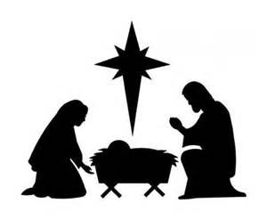
Visits and Spiritual Support
I love spending time with each of you, whether it’s to pray, reminisce, share a blessing, or simply enjoy a friendly conversation. If you’d like a visit—long or short—please just let me know. Jessie, my dog, the Joy Minister (may join us too, offering her own special brand of comfort and cheer.)

A Community of Light
As we move toward Christmas, may you feel wrapped in the warmth of God’s love and the kindness of this community. You are treasured. You are seen. And you are never alone.
Wishing you a December filled with peace, joy, and gentle rest,
Chaplain Kate (and Jessie the Joy Minister)
651-480-5925

Foot Care
Tuesday, December 23rd
Monday, December 29th
Cost is $15- Sign up in the Dining Room



Chaplain Corner ............... 5
A Christmas Poem……….….7
Silent Night….…………………8
Table of Contents
Activity Spotlight.................... 2
New Bus Celebration….......... 4
Birthdays………………............. 4


A Christmas Poem
The snow is falling, soft and white,
Blanketing the world in light.
The air is filled with songs and cheer,
For Christmas Day is finally here.

Windows sparkle with twinkling glow,
Wreaths and garlands hang in a row.
Stockings dangle, ready to fill,
With treats and toys, a heartening thrill.

Children’s laughter fills the air,
Excitement everywhere.
Families gather, hand in hand,
Sharing joy across the land.

Candles flicker, fires burn,
Time for love and hearts to turn.
Cookies baked, and cocoa sweet,
Bringing warmth in every treat.

Let us cherish, let us sing,
The hope and joy that Christmas brings.
A time for giving, peace, and cheer,
Merry Christmas to all, and a Happy New Year!

Bus Around Town
Wednesday, December 3rd
Wednesday, December 17th
9AM-3PM
-By Appointment Only-
Hastings Senior Health & Living offers a bus service around town from 9 AM to 3 PM by appointment only. To schedule a ride, call 651-480-6710 no later than noon the day before. This is a convenient way to get to doctor’s appointments, enjoy lunch with friends or family, and shop for as long or as little as you like.

Men’s Breakfast
Saturday, December 6th at 9AM
Call to all the men of Hastings Senior Health & Living for a morning of delicious breakfast and great conversations.

Christmas Card Making
Sunday, December 7th at 2:30PM
Join us for an afternoon of Christmas card making in the library. Christmas card kits with instruction available. Limit one per resident.

Cookie Decorating with Daycare Kids
Monday, December 8th at 10:30AM
We are excited to have our Halloween cuties join us for a morning of cookie decorating and maybe they might sing a song or two!

Activity Highlights
“Join us this December for festive fun, creative activities, and special community events for everyone to enjoy!”

Art Class
Monday, December 1st at 2PM
Artist Jess from HPAC will lead a 4-week art class, from suncatchers to basket making, with daily projects too. Join us Mondays in the 2nd floor puzzle room!

Music with Lucas
Tuesday, December 2nd at 6:30PM
Experience an evening of Lucas’s calming violin music as it surrounds the room with warmth and emotion.

Manicures
Wednesday, December 3rd at 3:30PM
Treat yourself to a relaxing manicure that leaves your hands looking polished and refreshed.

Kohls Outing
Friday, December 5th at 9:30AM
Looking for holiday deals or that perfect gift? Join us for a morning of shopping! Sign up in the Outing Book in the dining room.
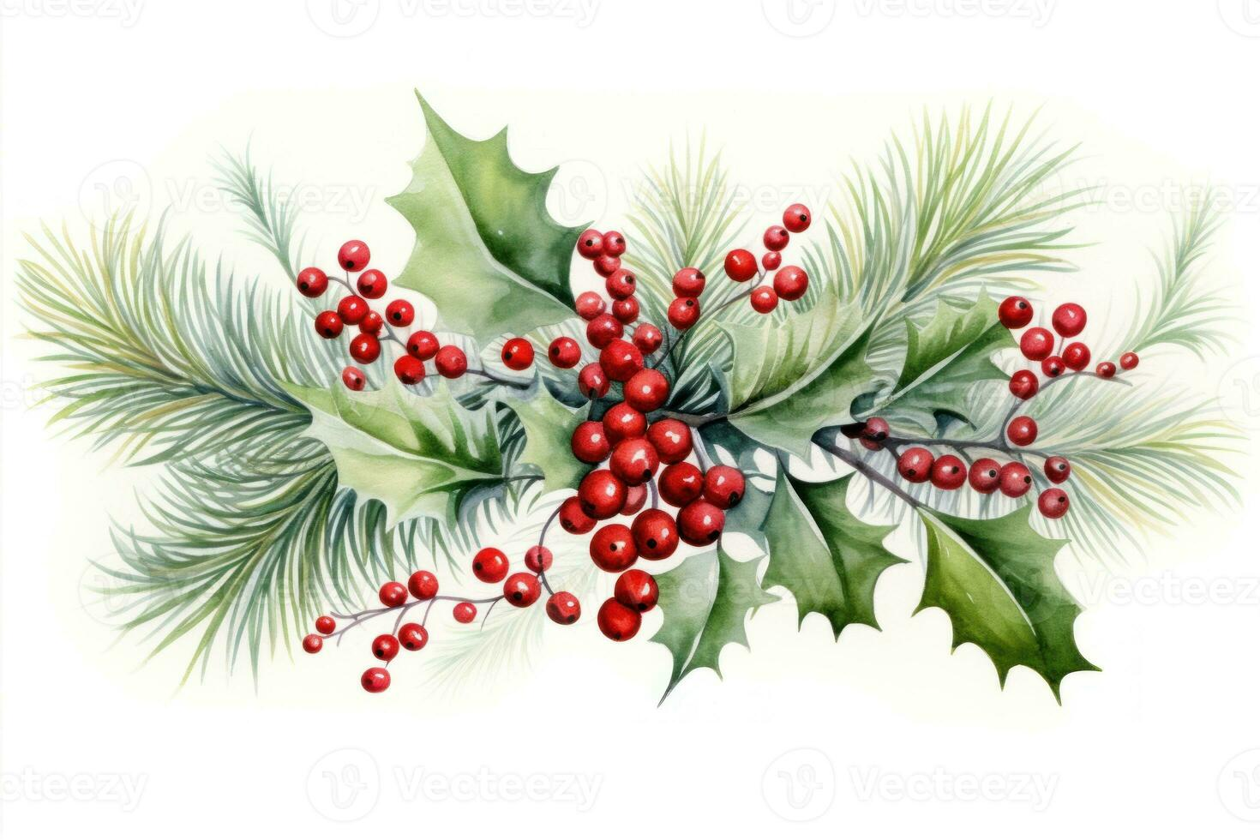
“And the December Cheer Continues!”
Popcorn
Friday, December 26th at 3PM
Join us for a Popcorn Social, a fun and casual gathering to enjoy popcorn and good company!

Memorial Service
Tuesday, December 30th at 2:30PM
Join us for a Memorial Service honoring members of our community who have passed away in the last six months.

Fun with Heather & Anna
Wednesday, December 31st at 3PM
Get ready for a fun-filled time with Heather & Anna, full of laughter, games, and good times!

Resident Holiday Party
Friday, December 19th at 3PM



Christmas Present Wrapping
Monday, December 22nd at 3PM
Bring your gifts and enjoy free Christmas gift wrapping by Heather to make your presents extra special.

Holiday Church Service
Tuesday, December 23rd at 2:30PM
Join our Christmas Ecumenical Service, a joyful gathering to honor the spirit of the season with friends and neighbors.

Exercise on Channel 3
Wednesday, December 24th at 10AM
Stay active from the comfort of your home by joining our senior exercise programs, available on our in-house channel 3.

Christmas Day
Although our office will be closed for the day, festive movies will play on our in-house channel 3.
(continue page 7)

New Bus Celebration
Tuesday, December 2nd
3-5PM

Thanks to the generosity of so many- our dream of a new Hastings Senior Health & Living Bus has come true! Please join us for an open house celebration with festivities, refreshments, and a bus blessing!

“The December spirit continues”
Trivia with Carmen
Tuesday, December 9th at 2:30PM
Join us for a fun-filled session of Trivia with Carmen, where laughter and friendly competition are guaranteed.

Winter Quilt Club
Wednesday, December 10th at 3:30PM
Join our Winter Quilt Club, where together, combining our unique talents, we’ll create beautiful quilts to welcome new residents to our community.

Rosary
Thursday, December 11th at 1PM
Join us in praying the Rosary in the library, where hearts come together in faith and contemplation. We will also have the Rosary throughout the month—please check the activity calendar for dates.

Music with Homesteaders Singers
Friday, December 12th at 3PM
As the Homespun Harmony group is searching for a new youth choir leader, some of its members miss us and will be coming to sing for our community.
“Even more holiday fun, friendship and fulfillment”

Live 2B Healthy
Mondays & Fridays at 10:15AM
Join us for Live 2B Healthy exercise and enjoy a fun, engaging way to stay active and strong!

Piano Music w/ Gretchen’s Piano Students
Tuesday, December 15th at 4PM
Enjoy a delightful performance as piano students come to play for our community.

$5 Holiday Bingo
Thursday, December 18th at 2:30PM
Get into the holiday spirit with $5 Holiday Bingo and a chance to win wonderful gifts from local stores!

Coffee Social
Saturdays at 9AM
Join us for Coffee Social, a cozy time to enjoy a cup of coffee and good conversation with friends.

Christmas Color Hour in Library
Sunday, December 21st at 2:30PM
Join us for Christmas Color Hour, a joyful time to get creative with colorful holiday-themed designs with friends.


Dave Carpenter
Band
Thursday, January 1st
3PM
Celebrate the New Year with the joy of music and festive melodies!



Craft Social
Saturdays at 3PM
Bring your crafts and hobbies to our Craft Social—it’s a wonderful opportunity to enjoy your projects alongside others.

Caroling in the Lobby
Sunday, December 14th at 4PM
Enjoy the joyful sounds of Christmas carolers from St. John’s Lutheran Church as they perform in our lobby.
(continue page 6)

December Birthdays
Nancy Hoff
December 1
Melva Jane Proechel
December 6
Kay Riessner
December 8
Kuei G.
December 13
Kay Smith
December 16
Jan Strick
December 18
Babita N.
December 18
Joy Pelzmann
December 21

Birthday Celebration
Wednesday, December 17th
2:30 PM

Chaplains Corner
Dear Park Ridge Family,
December has arrived, and with it comes the beauty of Advent! Advent and Christmas are the seasons I wait for all year long! Filled with hope, joy, and the quiet promise that God is drawing near, Advent invites us to slow down, breathe a little more deeply, and remember that even in the darkest days of winter, light is on its way.

A Season of Joy
Joy is an entire way of seeing our world! During Advent, joy often shows up in small, surprising places: a warm greeting in the hallway, a shared laugh over a puzzle, the sparkle of decorations going up. My hope is that you’ll allow yourself to notice those moments of joy each day. They are gifts meant just for you.

A Time to Rest
This season can also be busy and emotional. Many of us carry memories of loved ones, traditions, and holidays past. Advent gently reminds us that rest is holy, too. Take time to sit quietly with a cup of cocoa, listen to your favorite carols, or close your eyes and let peace fill your heart. God meets us in the stillness just as much as in celebration.

Advent Devotionals Are Available
I have Advent devotionals ready for anyone who would like one. These short daily reflections offer comfort, encouragement, and a moment of calm each day. Please let me know if you’d like a copy, I would be honored to bring one to you! (continue page 8)

Religious Offerings

Catholic Mass
Father Dave
Thursday, December 4
Confession-10AM
Mass 10:30AM—DR

Ecumenical Service
Pastor Kate
Wednesday, December 10
Tuesday, December 23
2:30 PM

Prayer Group
Thursdays at 11 AM
in the library

Our Saviors Lutheran Online Church Service
Sundays at 10:30 AM

Bible Study
Mondays 11AM
In the library
The History of the Candy Cane
The candy cane is one of the most recognizable symbols of Christmas, but its history stretches back several centuries. Legend has it that in the late 17th century, a choirmaster in Cologne, Germany, wanted to keep children quiet during the long Christmas services. He asked a local candy maker to create sugar sticks bent into the shape of a shepherd’s crook, representing the shepherds who visited baby Jesus. These early candy sticks were plain white and primarily served as a tool for teaching religious lessons.

By the 19th century, candy canes began appearing in the United States, where they became associated with the holiday season. The familiar red stripes and peppermint flavor were added over time, giving the candy its iconic appearance. The red stripes are often said to symbolize the blood of Christ, while the white represents purity, further connecting the treat to Christian traditions. Candy canes became a popular decoration, hung on Christmas trees and included in festive displays.

Today, candy canes are enjoyed around the world both as treats and decorations. While the original religious symbolism remains for some, many people simply enjoy their sweet peppermint flavor and festive design. From humble sugar sticks to colorful holiday icons, candy canes have grown to become a beloved part of Christmas celebrations, spreading joy to children and adults alike.

